Kubernetes Retail App Deployment
- Create Namespace
- Created a namespace as ajay-ns.
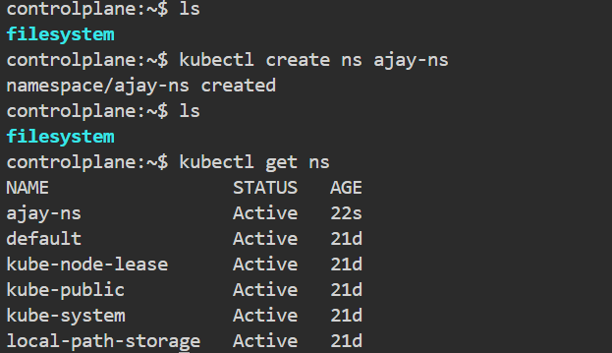

- Created a ConfigMap on
1.MONGODB_URI
2.SESSION_SECRET
3.PORT
- First need to create one yml file.
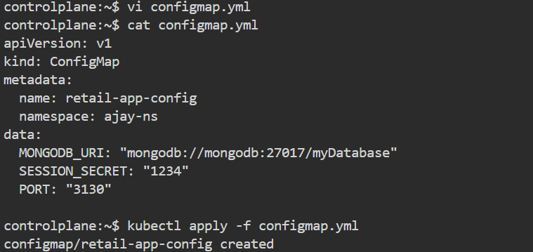

- Creating Secret
- It will store the sensitive data. (names, emails)
- It always stores a encoded values.
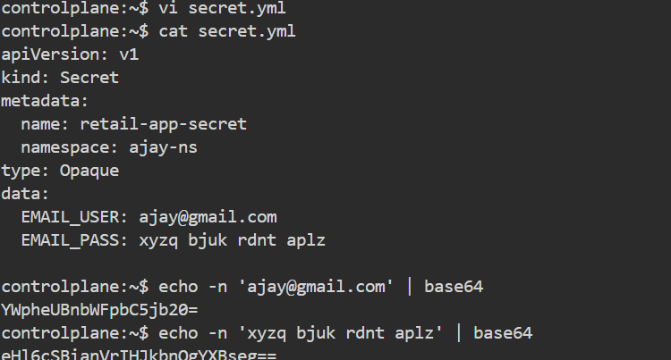
- We can decode this encoded values using
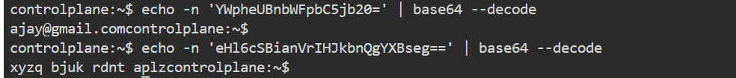
- Deployment Mongodb
- This is the mongodb deployment yaml file.
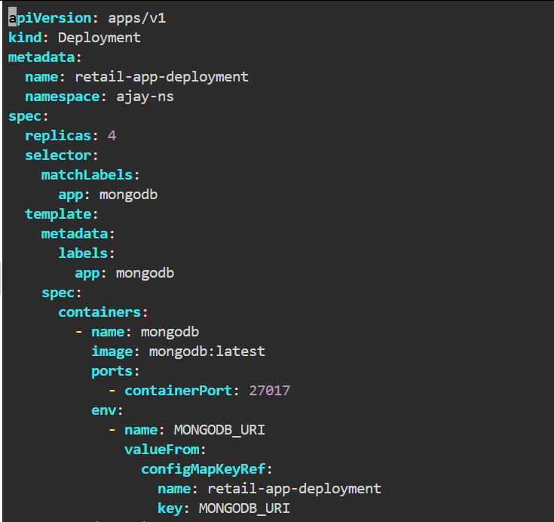

After applied
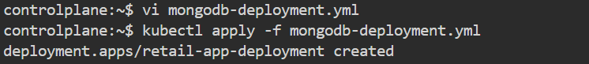

Creating mongodb service
- This the script for mongodb service yaml file.

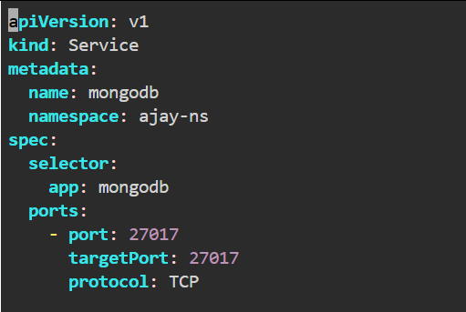

After applied
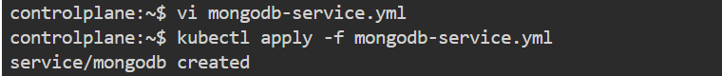

- Creation of retail application deployment
- Here is the script for retail deployment.
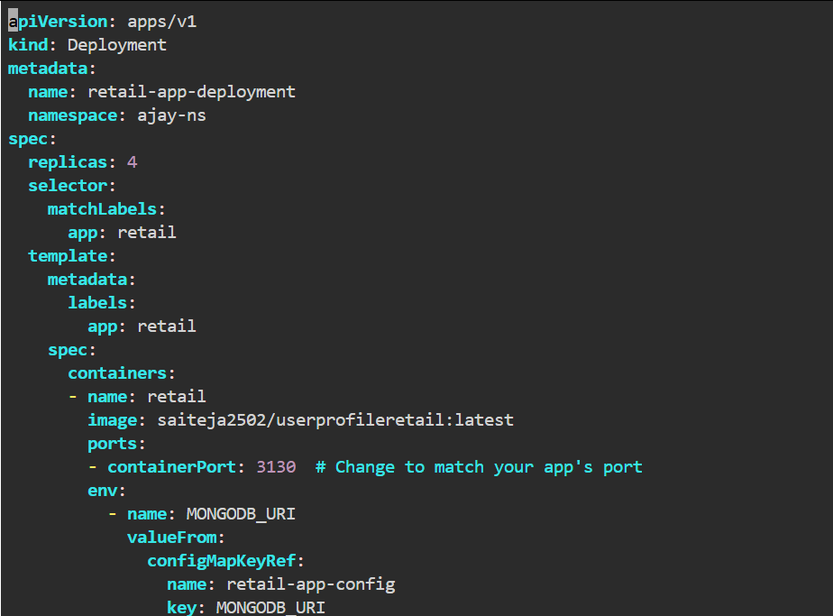
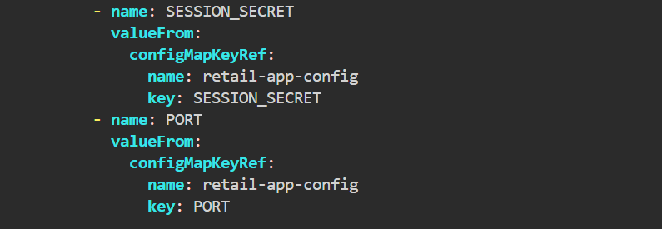
After applied the deployment file
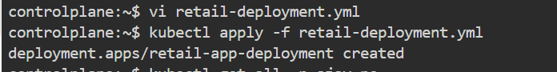

- Creating retail service yaml file
- This is the script for service yaml file

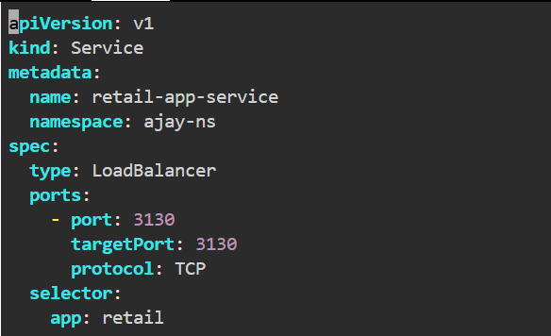
After applied
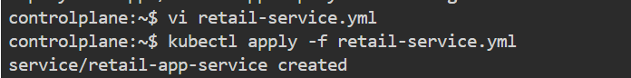

- Verification for config working
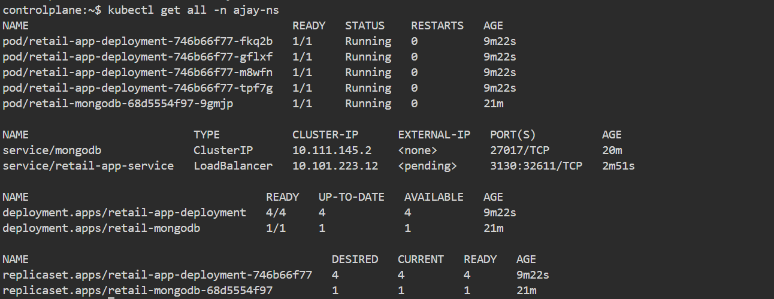

Final Result
- Created a namespace
- MongoDB Deployment
- Retail app deployed with replicas
- Application Successfully.

